

**DIGITAL UTRASONIC COOL MIST /WARM MIST HUMIDIFIER**

**ITEM# EE-8064**

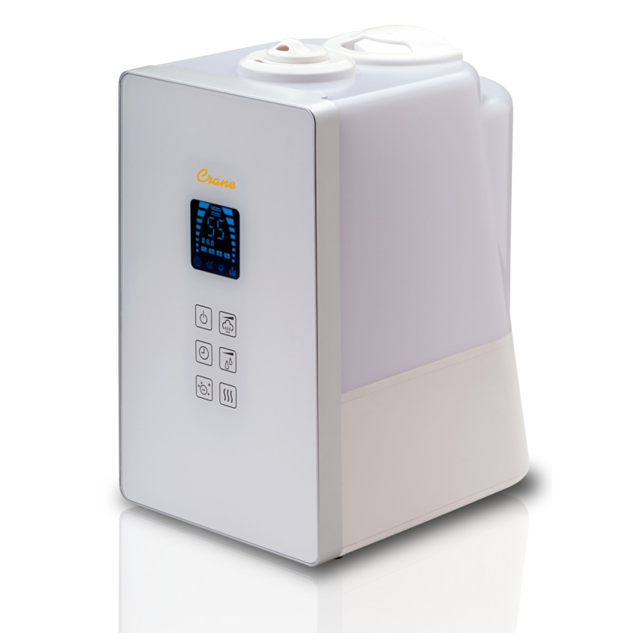



PLEASE READ AND SAVE ALL INSTRUCTIONS TO ENSURE THE SAFE AND EFFCTIVE USE OF THIS APPLIANCE.

|  |
| --- |
| **TABLE OF CONTENTS** |

|  |  |
| --- | --- |
| Table of Contents | P. 1 |
| Safety Instructions | P. 2-3 |
| List of Main Parts, Technical Specifications | P. 4 |
| Humidifier Features | P. 5 |
| Operation and Use | P. 5-8 |
| Digital Control Panel Instructions | P. 6 |
| Maintenance | P. 8 |
| Trouble Shooting | P. 9 |
| Customer Care | P. 10 |
| Warranty | P. 11 |

**For information about all CRANE Humidifiers,**

**please visit** [**http://www.crane-usa.com**](http://www.crane-usa.com)**.**

|  |
| --- |
| **IMPORTANT SAFETY INSTRUCTIONS** |

Thank you for purchasing a CRANE Ultrasonic Cool/Warm Mist Humidifier. Each unit has been manufactured to ensure safety and reliability. Before using for the first time, please read the instructions carefully and keep them for further reference.

**WARNING! READ AND SAVE THESE INSTRUCTIONS.** Failure to follow all of the instructions listed below may result in electric shock, fire and/or serious personal injury.

1. **DO NOT carry Water Tank by handle when it is filled with water. It is advisable to carry filled Water Tank with two hands.**
2. **DO NOT operate outdoors. This humidifier is intended for indoor use only.**
3. Always have water in the Water Tank when operating the unit.
4. Use only clean, cool tap water to fill the Water Tank (filtered or distilled water is recommended to avoid white dust if tap water is too hard; demineralization filters are also available for purchase at [www.crane-usa.com](http://www.crane-usa.com)). **DO NOT use hot water.**
5. Be sure that the Water Tank Cap is firmly tightened on Water Tank. Always have the Mist Lid in place while the unit is operating. Place the humidifier so the mist aims away from children, walls, furniture and electrical appliances.
6. Use only a 110-120VAC outlet.  **ALWAYS plug and unplug unit with dry hands to avoid electric shock.**
7. Never operate the unit with a damaged cord or plug.
8. Always place the unit on a smooth, flat, lint-free, non-metallic, waterproof and level surface and position unit away from direct sunlight. Keep the cord away from heated surfaces and areas where it could be walked on or tripped over. Unplug the unit when not in use and whenever you clean or move the unit.
9. Do not add medication of any type into the Water Basin or Water Tank. Do not cover any openings on the unit or insert objects into any openings.
10. The unit should not be left unattended in a closed room as the air could become saturated and leave condensation on walls or furniture. Leave room door partly open when humidifier is being operated.
11. When cleaning the inside of the humidifier, keep water away from the Fan Vent. **Turn off and unplug the humidifier to wipe the exterior** (except the electrical controls) with a damp cloth. Humidifier requires regular cleaning. Please refer to the CLEANING INSTRUCTIONS in this manual.
12. Do not tilt or tip the humidifier or attempt to empty or fill it while it is in operation.
13. Do not use a detergent to clean any parts of the unit that contain water. Detergent film dissolved in the water supply can interfere with the output of the unit. Instead, always use white vinegar mixed with water to clean the humidifier.

**SAVE THESE INSTRUCTIONS**!

|  |
| --- |
| **GENERAL SAFETY INSTRUCTIONS** |



**WARNING!** Read and understand all instructions. Failure to follow all instructions listed below may result in electric shock, fire or serious personal injury. The warnings, cautions, and instructions discussed in this instruction manual cannot cover all possible conditions and situations that may occur. It must be understood by the user that common sense and caution are a factor which cannot be built into this product, but must be supplied by the user.

**Do not** **let your child play with this appliance.**  Serious injury and electrocution might be possible. This humidifier has to be operated by an adult only. Children should be supervised to ensure that they do not play with the humidifier.

**SAVE ALL INSTRUCTIONS!**

**CAUTION:** A short Power Supply Cord is provided to reduce the risk of personal injury resulting from becoming entangled in or tripping over a longer cord. Extension cords are available from local hardware stores and may be used if care is exercised in their use. If an extension cord is required, special care and caution is necessary. Also the extension cord must be (1) marked with an electrical rating of 125 V and at least 13 A., 1625 W., and (2) the cord must be arranged so that it will not drape over the countertop or tabletop where it can be pulled on by children or accidently tripped over.

**ELECTRIC POWER**

If the electric circuit is overloaded by other appliances, your humidifier and/or appliances may not operate properly. The humidifier should be operated on a separate electrical circuit from other operating appliances.

**POLARIZED PLUG**

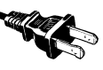

This humidifier has a polarized plug (one blade is wider than the other). As a safety feature to reduce the risk of electrical shock, this plug is intended to fit in a polarized outlet only one way. If the plug does not fit fully in the outlet, reverse the plug. If it still does not fit, contact a qualified electrician. Do not attempt to defeat this safety feature.



**SAFETY WARNING**

Although your humidifier is easy to operate, for your safety, the below warnings must be followed:

1. Do not place the humidifier near a heat source.
2. Never leave the humidifier unattended while connected to the electrical outlet.
3. To avoid any accidents, never cover the Mist Lid when the humidifier is in operation.
4. Use the humidifier on a smooth, flat, lint-free, non-metallic, waterproof, and level surface away from water.
5. Do not unplug from the wall socket by pulling on the supply cord.
6. The humidifier must be unplugged:
   1. Before either filling or emptying the Water Basin and/or Water Tank.
   2. Before any cleaning or maintenance is performed.
   3. After each use.
   4. If it appears to be faulty.

**THIS PRODUCT IS INTENDED FOR HOUSEHOLD USE ONLY.**

|  |
| --- |
| **LIST OF MAIN PARTS** |

|  |  |
| --- | --- |
| 1. Adjustable Mist Output Slot 2. Mist Lid 3. Digital Control Panel 4. Water Tank Handle   5   1. Water Tank 2. Water Tank Cap 3. Water Basin 4. Fan Vent 5. Nebulizer 6. Water Level Sensor/Float   10 | side view dig  3  2 |
| bottom tank  6 | top  9  8  7 |

4

1

|  |
| --- |
| **TECHNICAL SPECIFICATIONS:** |

|  |  |
| --- | --- |
| Rating Voltage | 120V |
| Frequency | 60Hz |
| Power Cool Mist | 30W |
| Power Warm Mist | 130W |
| Water Tank Capacity | 1.2 Gallon |
| Run Time Per Tank | Up to 24 hours |
| Humidifying Capacity | Up to 500 sq.ft. / 46 m2 |

|  |
| --- |
| HUMIDIFIER FEATURES |

**CRANE’S CLEAN CONTROL**

Anti-microbial Material: Proven to help reduce mold and bacteria growth up to 99.96% in the humidifier base*

*EMSL Test Report 151305654. Reduction of mold and bacteria is based on independent laboratory testing. EMSL report 151305654 results are based on the reduction of the bacteria in the humidifier base with Clean Control material, during continuous use. The humidifier base showed a reduction rate up to 99.96% of Gram Negative – Pseudomonas Aeruginosa after 8 hours.

**WARM AND COOL MIST**

You can select a warm mist or cool mist with this humidifier.

Humidifiers add moisture to the air, which helps ease coughing and congestion due to a cold, and relief from dry skin, chapped lips, and dry eyes. Warm mist and cool mist humidifiers are equally effective in humidifying the air.

* Warm Mist heats the water emitting a warm mist.
* Cool Mist emits a cool mist and will not affect the room temperature very much (if at all).

**ULTRASONIC HUMIDIFIER**

This is an Ultrasonic humidifier. The humidifier uses a metal diaphragm vibrating at an ultrasonic frequency, much like the element in a high-frequency stereo speaker to create mist. An ultrasonic humidifier is whisper quiet and produces a fine mist into the room.

|  |
| --- |
| OPERATION AND USE |

**BEFORE EACH USE**

**CHECK HUMIDIFIER PLACEMENT**

Place the Humidifier on an elevated, non-metallic, lint-free, waterproof, level surface at least 2 feet above the floor.

* **DO NOT** place the humidifier on carpet or a towel. The fan vent is located on the bottom of the humidifier base. The fan vent MUST NOT be obstructed.
* **DO NOT** place the humidifier on a wood surface or near furniture that can be damaged by too much moisture.

**CHECK WATER LEVEL SENSOR**

Make sure that the Water Level Sensor is secured properly and not obstructed.

### CAUTION

**DO NOT operate the humidifier without water in the Water Tank.**

**DO NOT plug or unplug the Power Cord with wet hands as electric shock could occur.**

**DO NOT USE ANY ADDITIVES IN THE WATER**

Additives – such as oils, fragrances, or vapor/steam medications – cannot be added to the water. This humidifier is not made to take additives. Any use of additives will void the manufacturer’s warranty.

|  |
| --- |
| **DIGITAL CONTROL PANEL INSTRUCTIONS** |

NOTE: Use on/off button to reset the humidifier.

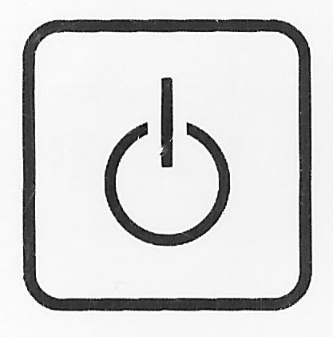

**ON/OFF**- Switch humidifier on/off by pressing this button.

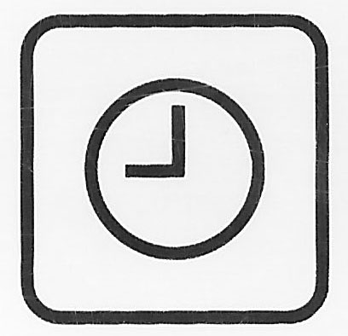**TIMER** – The lower bar of numbers on the digital display are for the timer. You can set the timer for 1- 12 hours or C for continuous run up to 24 hours. There are 4 numbers on the digital screen (1,2,4,5). Press timer button to select desired hours of operation. For example for 8 hours the digital display will be **08** and the lower bar will show numbers 1,2 and 5 = total 8. The digital number will eventually disappear but the lower numbers will stay. **NOTE**: C indicates continuous run. C will appear after pressing the timer button 12 times.

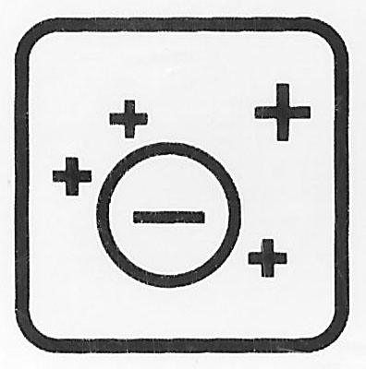

**IONIZER** – Press this button to enrich mist with negative ions to freshen the room air.

**MIST OUTPUT CONTROL**- The first bars of numbers on the digital display are for the mist output. Low - 1 (3 bars illuminate on either side), Med-2 (6 bars illuminate on either side), High-3 (8 bars Illuminate on either side).

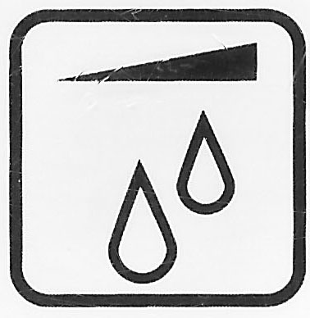**SET HUMIDITY LEVEL** – Press this button to set desired humidity level. You can set the humidity level between 40% - 80%. The recommended humidity level is between 40% - 60%. Press button 10 times for continuous output.

**COOL/WARM MIST SELECTOR**- When humidifier is on, cool mist will automatically start. To select warm mist, press button, when blue sun symbol appears on the bottom right corner of display the warm mist will activate within 15 minutes.

**AUTO SHUT OFF** –When the water level gets low, the humidifier will automatically shut off. A red light in the lower right side of digital display will flash indicating the water level is low and the humidifier mist has turned off.

|  |
| --- |
| **ASSEMBLY** |

**ALWAYS use fresh cool water when operating the humidifier.**

|  |  |
| --- | --- |
| 1. Turn Water Tank upside down and unscrew Water Tank Cap. |  |
| 1. Fill Water Tank with cool water. **DO NOT** fill water all the way to the rim.   **DO NOT CARRY FULL WATER TANK BY HANDLE**.  **ALWAYS HOLD FULL WATER TANK WITH TWO HANDS.**  **DO NOT** use hot water. Use cool tap water.  **DO NOT** add any medication, essential oils, or salt.  **DO NOT** pour water into Mist Outlet Channel.   1. Screw Water Tank Cap back onto Water Tank. Turn the Water Tank over and place on Water Basin, making sure it fits perfectly.   **Note:** Do not attempt to move the humidifier while Water Tank is placed on Water Basin. Doing so may cause leakage of water and/or Water Basin to overfill.   1. Plug the power cord into a wall socket and turn on the unit by using the Control Knob. 2. Use the Digital Control Panel to select the mode of your choice. The blue Power Indicator Light will illuminate. In a few seconds, mist will start emitting. 3. Use the Digital Control Panel to adjust the intensity of the mist output.   **SET THE CORRECT HUMIDITY OUTPUT:** Adjust the Digital Control Panel so that the mist rises up to be absorbed by the room air. Do not set the mist output too high, as the mist cannot be absorbed by the air and may accumulate on the surfaces around the humidifier.   1. When the humidifier runs out of water, the humidifier will automatically shut off and the mist will stop. The Low Water Indicator Light will illuminate red. This safety feature uses a water level sensor to stop the Nebulizer once the water level sinks below the required level in the Humidifier Base.   **Note: The indicator light on the humidifier will remain on. The red light indicates that the humidifier is turned on and needs to be refilled.** |  |

**A NOTE ABOUT HUMIDITY**

* It is best to keep the humidity level at about 40%-50% of relative humidity.
* In cold weather, windows and even some walls may fog or develop frost from excessive indoor humidity. If this occurs, reduce the mist output setting to avoid damage from condensed water dripping onto windowsills.
* Too much humidity in the room may allow moisture to accumulate on surfaces where bacteria and fungi can grow. Moisture that gathers may also damage furniture and walls, especially wallpaper.
* To reduce excessive humidity, especially in small rooms, leave the room door open and adjust the mist intensity control setting.

|  |
| --- |
| **MAINTENANCE** |

It is important to keep ultrasonic cool mist [humidifiers](http://www.ehow.com/how_5045637_clean-cool-mist-humidifiers.html) clean. Cleaning and disinfecting on a regular basis is important for maintaining the performance of your humidifier

**IMPORTANT**

**DO NOT** leave water in Water Tank or Water Basin when unit is not in use as it may result in the buildup of mineral deposits and bacteria that can inhibit the output efficiency of the humidifier. If water remains in the Water Tank for more than a day or two, bacterial growth is possible.

**DAILY MAINTENANCE**

1. Always turn off and unplug from outlet before cleaning.
2. Empty water from the water tank and water basin daily.
3. Wipe and dry water basin with a [clean](http://www.ehow.com/how_5045637_clean-cool-mist-humidifiers.html), dry cloth or paper towel.
4. Replace the water tank.

**WEEKLY MAINTENANCE**

1. Always turn off and unplug from outlet before cleaning.
2. Empty water from the water tank and water basin.
3. Fill the water tank with about a half-gallon of warm water. Add 2 Tablespoons of white vinegar. Shake vigorously and let sit for 20-30 minutes. Shake vigorously again and empty the water. Rinse water tank.
4. Make similar white vinegar/water solution. Pour into water basin. Let sit for 20-30 minutes, and then empty. Rinse water tank. Wipe dry with a clean, soft cloth.
5. Wipe the exterior surface water tank and water basin with a soft, dry cloth. NEVER IMMERSE WATER BASIN IN WATER.

**END-OF-SEASON MAINTENANCE & STORING YOUR HUMIDIFIER**

1. Always turn off and unplug from outlet before cleaning.
2. Empty water from the water tank and water basin.
3. Disinfect water tank and water basin with the white vinegar and water solution.
4. Make sure that water tank has air dried without the water cap secured.
5. Make sure the water basin and water tank are completely dry before end of season storage. Store the humidifier in a cool dry place.
6. **DO NOT** place any heavy items on top of humidifier during storage as this may result in possible damage of the humidifier.
7. Store the cord in a clean, dry location away from metal objects. Always check the plug before use to ensure metal items have not become attached.

|  |
| --- |
| **TROUBLE SHOOTING** |

**DO NOT attempt to repair the motor or nebulizer yourself. If the humidifier continues to not operate please contact Crane Customer Care: 888-599-0992 or** [**customer-service@crane-usa.com**](mailto:customer-service@crane-usa.com)**.**

|  |  |
| --- | --- |
| **Problem** | **Solution** |
| *If humidifier does not have any power:* | * Ensure unit is properly plugged into a power outlet. * Check that the Control Knob is turned to the ON position. * If Power On indicator light does not come on, contact Crane Customer Care. |
| *If there is a strange odor:* | * Clean the Water Tank with the water and vinegar solution and rinse with clean water. * Leave the empty Water Tank open for some time (without the Water Tank Cap attached) in a cool place. |
| *The digital display is on, but there is no mist:* | * Unplug and re-plug into power source. * Check that there is water in the tank. * Check for possible mineral deposits on the nebulizer. * Make sure that nothing blocks the mist output slot. * Check that the fan vent on bottom of humidifier is not blocked. * Empty the humidifier and rinse the water basin with cool tap water and allow to dry for 30 minutes. * If this does not solve the problem, please contact Crane Customer Care. |
| *White dust appears and settles outside the humidifier:* | * Area tap water may have too many minerals. Change to filtered or distilled water or purchase a Crane demineralization filter cartridge ([www.crane-usa.com](http://www.crane-usa.com)). |

|  |
| --- |
| **CUSTOMER CARE** |

If you have any questions with regard to the operation of this humidifier or are in need of a spare part, please contact Crane Customer Care.

**Crane USA, Inc.**

1015 Hawthorn Dr.

Itasca, Illinois 60143

Toll Free: 1-888-599-0992 (Monday - Friday 9:00am - 4:00pm CST)

Email: [customer-service@crane-usa.com](mailto:customer-service@crane-usa.com)

Website: [http://www.crane-usa.com](http://www.wk-usa.com)

**NOTE:** Spare Parts can also be purchased online at [http://www.crane-usa.com](http://www.wk-usa.com).

|  |
| --- |
| **ENVIRONMENTAL PROTECTION** |



If the humidifier should no longer operate, please be sure to dispose of the unit in an environmentally friendly way by taking it into a public collection point. Please do not place broken humidifiers with your regular household waste.

